- Render a list of products using `.map()` with stable `key` props.

Coding:
import { useState } from "react";

function Map(){
const [productlist,setProduct] = useState([
{ id: 1, name: "Laptop" },
{ id: 2, name: "Mobile" },
{ id: 3, name: "Headphones" },
{ id: 4, name: "Keyboard" },
{ id: 5, name: "Mouse" },
]);

return(
<div>
<ul>{
productlist.map((item) => <li key={item.id}>{item.name}</li>)
}
</ul>
</div>
);
}

export default Map;

Output:
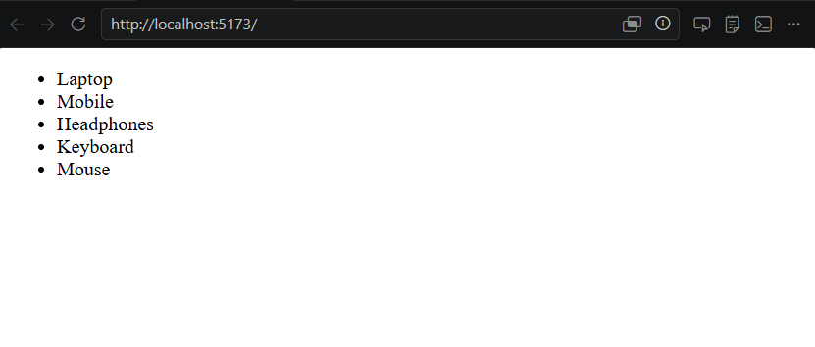

- Show 'No products available' when the list is empty using a conditional (ternary/&&).
Coding:
import { useState } from "react";

function Noproduct(){
const [productlist,setProduct] = useState([
{ id: 1, name: "Laptop" },
{ id: 2, name: "Mobile" },
{ id: 3, name: "Headphones" },
{ id: 4, name: "Keyboard" },
{ id: 5, name: "Mouse" }
]);

return(
<div>
{productlist.length >0 ? <ul>{productlist.map((item) => <li key={item.id}>{item.name}</li>)}
</ul> : <h1>No Product Available</h1>}

</div>
);
}

export default Noproduct;

Output:
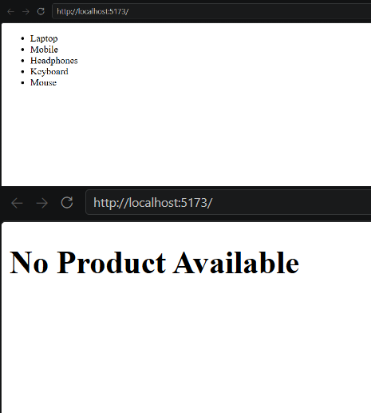

- Implement a filter input that filters the rendered list by product name.

Coding:
import { useState } from "react";

function Filterbox(){
const [productlist,setProduct] = useState(["Laptop","Mobile","Headphones","Keyboard","Mouse","Camera"]);
const [list,setlist] = useState([]);

function filtertext(){
let a = document.getElementById("fil").value;
if (a !== ""){
let start =[]
let middle = []
productlist.forEach(element => {
if(element.toLowerCase().startsWith(a.toLowerCase())){
start.push(element);
}else if(element.toLowerCase().includes(a.toLowerCase())){
middle.push(element);
}
setlist([...start,...middle])
});
}else{
setlist([])
}
}

return(
<>
<ul>{productlist.map((ele) => <li>{ele}</li>)}</ul>
<input type="text" id="fil" onChange={filtertext}></input>
<ul>{list.map(ele => <li>{ele}</li>)}</ul>
</>
);
}
export default Filterbox;

Output:
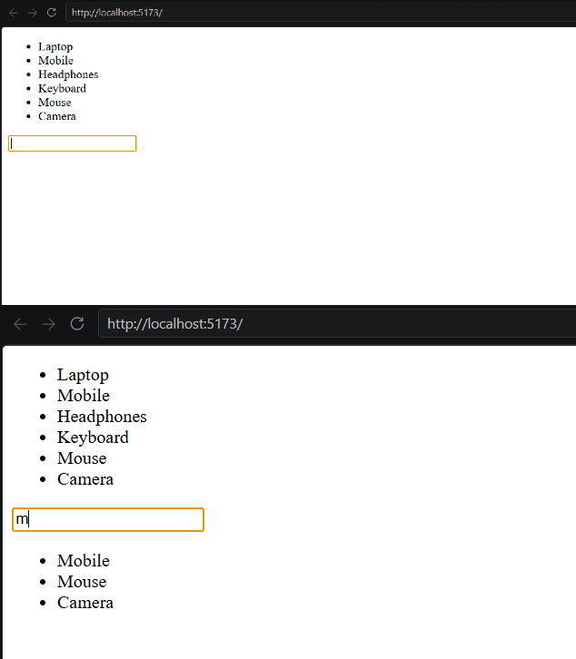

- Highlight an item on hover using conditional class application.

Coding:
import { useState } from "react";
import "./Hover.css";

function ConditionalClass() {

const [hovered, setHovered] = useState(null);

const products = ["Laptop", "Mobile", "Mouse"];

return (
<ul>
{products.map((item, index) => (
<li
key={index}

className={
hovered === index ? "highlight" : "normal"
}

onMouseEnter={() => setHovered(index)}
onMouseLeave={() => setHovered(null)}
>
{item}
</li>
))}
</ul>
);
}

export default ConditionalClass;

Hover.css:
.normal {
background-color: lightgray;
}

.highlight {
background-color: blue;
color: white;
}
Output:
